Desktop Email Clients

🖥️ What Are Desktop Email Client?
# Source: AI Source: Provided by: [Data Path: Persons Table -> ID Column: 1, Name_En Column: Motasem Essam] -> From: [Chatgpt (GPT‑5 Mini)] on [1/21/2026]
A desktop email client is an application installed on your Windows, macOS, or Linux computer that allows you to send, receive, and manage emails without using a web browser.

📥 What Desktop Email Clients Do
# Source: AI Source: Provided by: [Data Path: Persons Table -> ID Column: 1, Name_En Column: Motasem Essam] -> From: [Chatgpt (GPT‑5 Mini)] on [1/21/2026]
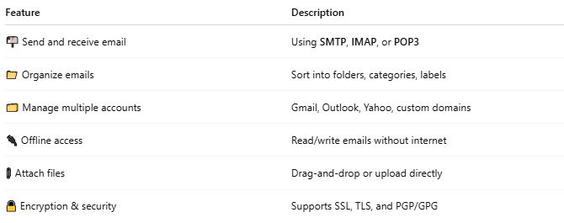

Feature | Description
📬 Send and receive email | Using SMTP, IMAP, or POP3
📁 Organize emails | Sort into folders, categories, labels
🗂 Manage multiple accounts | Gmail, Outlook, Yahoo, custom domains
🔌 Offline access | Read/write emails without internet
📎 Attach files | Drag-and-drop or upload directly
🔒 Encryption & security | Supports SSL, TLS, and PGP/GPG

🧰 Popular Desktop Email Clients
# Source: AI Source: Provided by: [Data Path: Persons Table -> ID Column: 1, Name_En Column: Motasem Essam] -> From: [Chatgpt (GPT‑5 Mini)] on [1/21/2026]
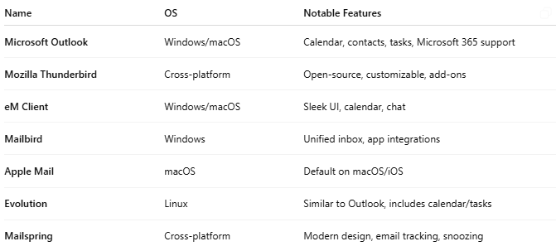

Name | OS | Notable Features
Microsoft Outlook | Windows/macOS | Calendar, contacts, tasks, Microsoft 365 support
Mozilla Thunderbird | Cross-platform | Open-source, customizable, add-ons
eM Client | Windows/macOS | Sleek UI, calendar, chat
Mailbird | Windows | Unified inbox, app integrations
Apple Mail | macOS | Default on macOS/iOS
Evolution | Linux | Similar to Outlook, includes calendar/tasks
Mailspring | Cross-platform | Modern design, email tracking, snoozing

🔁 Desktop vs Webmail vs Mobile Clients
# Source: AI Source: Provided by: [Data Path: Persons Table -> ID Column: 1, Name_En Column: Motasem Essam] -> From: [Chatgpt (GPT‑5 Mini)] on [1/21/2026]
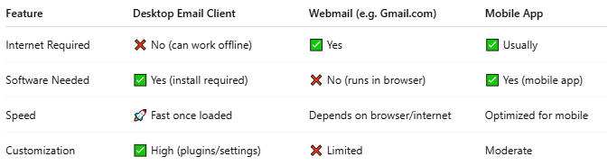

Feature | Desktop Email Client | Webmail (e.g. Gmail.com) | Mobile App
Internet Required | ❌ No (can work offline) | ✅ Yes | ✅ Usually
Software Needed | ✅ Yes (install required) | ❌ No (runs in browser) | ✅ Yes (mobile app)
Speed | 🚀 Fast once loaded | Depends on browser/internet | Optimized for mobile
Customization | ✅ High (plugins/settings) | ❌ Limited | Moderate

✅ When to Use a Desktop Email Client
# Source: AI Source: Provided by: [Data Path: Persons Table -> ID Column: 1, Name_En Column: Motasem Essam] -> From: [Chatgpt (GPT‑5 Mini)] on [1/21/2026]
Use one if you:
- Work with email all day
- Need offline access
- Manage multiple accounts
- Want more control and customizability
- Prefer storing emails locally

🧠 Summary
# Source: AI Source: Provided by: [Data Path: Persons Table -> ID Column: 1, Name_En Column: Motasem Essam] -> From: [Chatgpt (GPT‑5 Mini)] on [1/21/2026]
A desktop email client is software you install on your computer to manage email.
It offers powerful features, offline access, and supports multiple email providers — all from your desktop.

